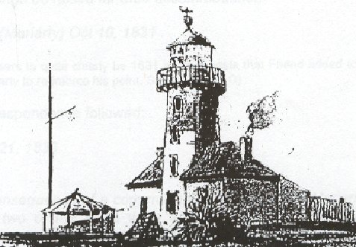 **George Town & District Historical Society Inc.**

**14th Biennial Conference**

**More Convict Stories**

**of northern Van Diemen's Land/Tasmania**

**When: Sunday 9 November 2025 (**reg. **8.45 am for 9.15 am start to 4.15 pm)**

**Where: Performing Arts Centre, Port Dalrymple School 147-185 Agnes St, George Town**

**(Turn right into Agnes St after the United Petrol Station at the first intersection as you enter the town. Proceed north to Cimitiere St, then continue 200m to the High School entrance.)**

**Cost: $45 (includes morning tea, lunch and afternoon tea)**

**Speakers & Topics (order may vary):**

**Colette McAlpine *Ann Carey: convict, settler, mother. 1772 - 1830***

**Maureen Mann *The ‘useless' ones: some offences from 1830s Longford Lower Court records***

**Colette & Maureen *Female Convicts Research Centre website and Database***

**Libby Prescott *Should I stay or should I go? Port Sorell’s Convicts – leavers and remainers.***

**Matthew Cunneen *Where did they go? The emigration of VDL’s convicts***

**Doug Watkins *Mathew Kirk and Elizabeth Edwards - Port Dalrymple 1804***

**Chris Woods  *Orphans of Northern Van Diemen’s Land/Tasmania***

**Jeanette Thompson *Felon or Forager: The Life of Thomas Jeffries (bushranger)***

**Cut here** ----------------------------------------------------------------------------

**2025 Conference Registration Form**

**Please return form with payment** **($45** per person - cheque/money order accepted) **by Friday 31 Oct**

**Treasurer, George Town & District Historical Society Inc.,**

**73 Low Head Rd, George Town, TAS. 7253 Phone: 0404 447 216**

**Name(s)...............................................................................................................................................................................................**

**Address.....................................................................................................................Telephone......................................................**

**Email..............................................................................No. attending.................Amount Enclosed $..................................**

**Any Dietary Requirements............................................................................................................................................................**

or you can **Direct Deposit to: COMMONWEALTH BANK OF AUSTRALIA - BSB 067-023**

**Account Name: George Town & District Historical Society Inc. Account No. 1008 2458**

**PLEASE put your name in the details field so that we can identify the payment, and also send an email to advise payment and details as above to:**

**The Treasurer, Carol Thomas**  [**carolann.thomas@bigpond.com**](mailto:us@thegrovetas.com)